Providing lab results requires everyone’s cooperation. The process of drawing the blood is the most crucial step to obtaining accurate results. **Thank you** for all of your hard work and dedication to providing the best care possible for our patients.

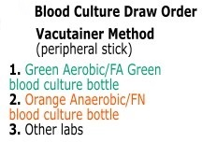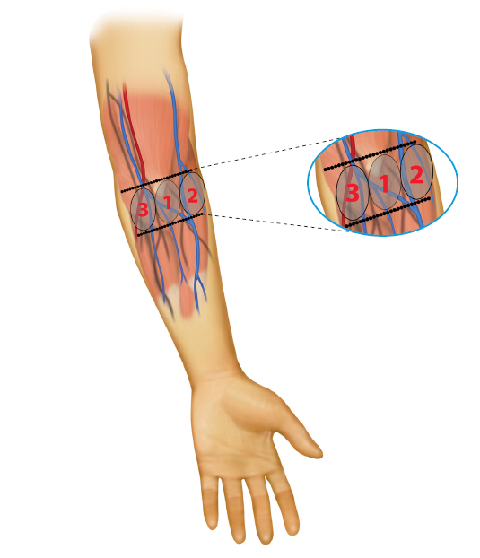

Preferred Venipuncture Sites

Use a **21 or 23 gauge needle** whenever possible based on the patient’s vein to be accessed

1. Median cubital vein
2. Median cephalic vein
3. Median basilic vein

(Use basilic vein **only** if no other vein is available)

**HOW DO THESE PROBLEMS AFFECT TEST RESULTS?**

|  |  |
| --- | --- |
| **Hemolysis** | It may cause falsely **decreased** results for tests such as direct bilirubin, RBCs, HCT, and aPTT.  It may cause falsely **elevated** results for tests such as potassium, ammonia, magnesium, phosphorus, AST, ALT, LDH and PT |
| **Clotted** | Falsely **decreased** platelets (plt) and hemoglobin (Hgb), and the PT and PTT can be either falsely increased or decreased depending on the size and composition of the clot |
| **IV Contamination** | Affects many analytes due to a dilution effect and contamination of the fluids/medications. Examples include falsely **decreased** Hgb, plt, and WBC count, falsely **increased** sodium (Na), Chloride (Cl), and PT/PTT |
| **EDTA Contamination in a Chemistry tube** | Falsely **increased** K and falsely **decreased** Calcium (Ca) |
| **Delayed turnaround time** | Recollecting the sample adds time patients wait for lab results |
| **Prolonged tourniquet time** | Possible hematoma formation and falsely **elevated** results for all protein based analytes, Hgb, and other cellular elements. **Do not exceed 1 minute** |
| **Patient ID Errors** | Potential for serious injury to the patient if clinical decisions or blood products given based on mislabeled specimens |

**HEMOLYZED SPECIMENS**

Hemolysis is caused when red blood cells (RBCs) are destroyed and hemoglobin is released into the plasma or serum. Hemolysis can be seen after the blood sample is spun down in a centrifuge. The plasma or serum will be pink (slight hemolysis) to red (gross hemolysis).

|  |  |
| --- | --- |
| **Patient Conditions that May Cause Hemolysis**   * Hemolytic anemia * Liver disease * Transfusion reactions | **Procedural Practices that May Cause Hemolysis**   * Collecting blood when starting an IV * Collecting from a vascular access device (VAD) * Using a needle with a bore too small for the vein * Mixing the tubes too vigorously or rough handling during transport * Underfilled tubes * Excessive force on the syringe plunger   + keep < 1 mL dead space * Frothing of the blood caused by improper fit of the needle on a syringe * Forcing the blood from a syringe into an evacuated tube * Drawing blood from a vein that has a hematoma * Continuing sluggish draws caused by collapsed veins or improper needle placement * Excessive squeezing of the site when obtaining a skin puncture specimen |

**UNDERFILLED/OVERFILLED TUBES**

* Most tubes have additives to prevent clotting or stabilize analytes when the correct amount of blood is added.
* Each test also requires a minimum volume of blood for pipetting and follow-up testing
* Underfilled/overfilled tubes can lead to **erroneous lab results** for some tests.
* Results can be falsely reduced by dilution if underfilled or the specimen may clot if overfilled due to insufficient anticoagulant.
* 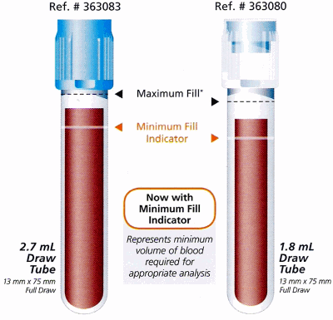**Blood culture bottles must be filled to the fill line**, 8-10ml adults and 1ml infant
* The light blue sodium citrate tube for coagulation testing must be filled to the line.
  + There is a crucial 9:1 ratio of blood to anticoagulant.
  + If the ratio is disturbed by **either** **too little or too much blood** (the tube is filled up to the cap) the lab results will be inaccurate.
* It is also very important to draw a **discard tube before collecting a sodium citrate tube** because of tissue thromboplastin (a clotting factor that is activated when the skin is pierced).
  + If using a butterfly, a discard tube ensures the tube will fill properly by getting rid of the air in the tubing.

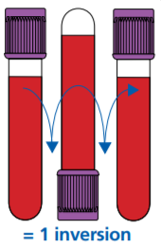**CLOTTED SPECIMENS**

Lack of or inadequate mixing of tubes is the major cause of clot formation. To help stop the specimen from clotting, mix the tube by **gently** inverting it a minimum of 3 times **immediately** after filling it with blood. Then continue to **gently** invert the tubes a total of **8 times** to completely mix. Line draws into a syringe must be transferred by piercing the vacutainer cap without delay and gently mixed to avoid clotting.

|  |  |
| --- | --- |
| **ASEPTIC TECHNIQUE**   * Perform hand hygiene * Clean with 70% alcohol or >0.5% Chlorhexidine Gluconate sponge prep (Chloraprep) with back and forth motion * Related imageRelated imageUse needles **one time only** | **IV CONTAMINATION**   * Obtaining specimens from indwelling lines or vascular access devices can be a potential source of test error due to hemolysis or contamination with fluid and/or medication due to incomplete flushing of the collection site. **Whenever possible, blood must be collected from the opposite arm of VADs and infusions.** If blood needs to be collected on an arm in which an infusion is taking place, please refer and adhere to the [*Intravascular Access Devices, Peripheral and Central (Nursing)*](https://policytech.osumc.edu/docview/?docid=61021&anonymous=true) policy. |

**IMPROPERLY COLLECTED OR PATIENT ID ERRORS**

Correct identification of patient specimens **using 2 patient identifiers** is essential for reporting accurate laboratory results. Documenting specimen collection via scanning and proper label placement is critical to safe, accurate, and timely lab completion. Follow the steps outlined in the [IHIS specimen collection tip sheets](https://onesource.osumc.edu/departments/IHIS/Pages/Tip%20Sheets.aspx?RootFolder=%2Fdepartments%2FIHIS%2FTip%20Sheets%2FLabs%20and%20Results&FolderCTID=0x012000F48BFC14987803418B02C012E137C8D8&View=%7B2C37F870%2DF76C%2D4438%2DAC38%2D202EE771B0EB%7D) with the following key takeaways:

* Always **Scan Before you Move** to complete the collection documentation, including clicking **[Accept]**
* Always document the source for specimens other than blood **including specimen type and collection site**

A variety of blood collection tubes and urine preservatives are necessary to maintain specimen stability until testing can be performed in the laboratory. Refer to the Lab Testing Menu on *OneSource-MyTools*or the lab test label for acceptable tube types.

[**https://clinicallabs.osumc.edu/Pages/TestCatalog.aspx**](https://clinicallabs.osumc.edu/Pages/TestCatalog.aspx)

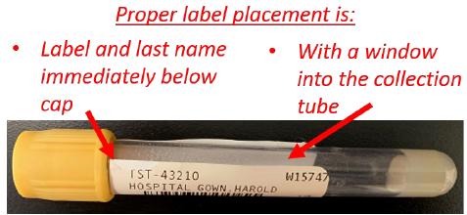

**TOP**



**Label**

**Then**

For more comprehensive information, refer to the [Standards for Acceptable Clinical and Anatomic Pathology Specimen Collection](https://policytech.osumc.edu/docview/?docid=55120&anonymous=true), [Intravascular Access Devices, Peripheral and Central (Nursing)](https://policytech.osumc.edu/docview/?docid=61021&anonymous=true), and [Blood Culture Kit Tip Sheet](https://onesource.osumc.edu/sites/NursingSkills/Documents/blood-culture-kits-Final.pdf#search=blood%20culture) on *OneSource-MyTools*

**________________**

**THANK YOU**