|  |  |  |  |
| --- | --- | --- | --- |
| **Laboratory:** | **Document Type:** | **Original Date Adopted:** | **Previous Document:** |
| James Laboratory | Policy | 4/6/2015 | James-35 Revision 5 |

|  |  |  |
| --- | --- | --- |
| **Document Author:** | **Document Owner:** | **Acknowledgement / Required Copy Holders*:** |
| Clint Walker | Jaime Swartzwelder | All James laboratory personnel |

|  |
| --- |
| **Approval*:** |
| Laboratory Medical Director(s): University Hospitals Medical Director |

|  |
| --- |
| **\*Approval and Acknowledgements\*** |
| Refer to QPulse system and Document Details report for laboratory directors(s)’ electronic signature approval, employee acknowledgment and effective date. |

1. **POLICY** 
   1. Policy for use during “down time” situations within the laboratory.
2. **PURPOSE OF DOCUMENT**
   1. This procedure is to be utilized in the event of laboratory “downtime”. “Downtime” refers to the loss of the ability to run, transmit, report, call patient results, etc. This can be due to computer based information malfunction, loss of phone system, power loss, loss of the instrument feed water system, etc.
   2. Each “down time” situation is unique in some way, this document is designed to give guidance in each area and not necessarily to be followed precisely which is dependent on the situation occurring.
3. **SCOPE OF DOCUMENT**
   1. To be used by James Laboratory personnel in the event of a down time situation.
4. **RESPONSIBILITY** 
   1. James Lead Technologist, Safety Officer, and Laboratory Manager.
5. **INSTRUMENT DOWN TIME**
   1. Back up Instruments
      1. If there is an instrument that is unable to be used due to maintenance or it is in need of repair specimens should be run on other available instruments that are located in the James Lab. Specimens for those areas for which we do not have a backup unit should be sent to CCL.
   2. Sending out lab work
      1. The specimens going to CCL must be put on a packing list to UH.
      2. Call CPA and the appropriate CCL bench area. A list of phone numbers can be found; *L:\Shared\Pathology\James Tower Lab\Clerical* (See the phone lists)
      3. Contact the James clinics and ED units to inform them of the potential delay in results.
6. **COMPUTER DOWN TIME** 
   1. **James Laboratory basic overview and general information for IHIS or Beaker downtimes**
      1. Call the MedCenter IT HELP desk (3-3861) when you realize information is not transmitting.
      2. When IHIS is down, labels will not be able to print at collection. Specimens will be sent with a lab Downtime Requisition.
      3. Make sure your instruments are set to “Print All” functions (see specific instructions for each area)
      4. Open the black ‘Downtime’ box and locate the pre-printed downtime labels to use for identifying specimens. Put these in the processing areas.

Using 4-part labels, Write the patient information and tests ordered on the main label, one for each sample tube, and place the small CID labels on the requisition for matching later once orders are placed in the system.

* + 1. In hematology, locate the labels for reporting manual differentials, and also the stickers for documenting critical result communications (for all areas).
    2. **ED prefers to have results sent to them via the pneumatic tube system**
       1. **Use the chart of tube station numbers below for the respective clinics and ED pods**

|  |  |
| --- | --- |
| **Clinic Tube Stations** | |
| **Location in Beaker** | **Tube Station** |
| REM, Fast Track (44-50) | 200 OR 374 |
| RM 1-34 | 374 |
| RM 35-56, Corr, BC | 300 |
| CT1APH | 396 |
| CT5JCH | 350 |
| CT5CTU | 391 |
| CT5HON, CT5HNS, HEMJ | 370 |
| CT1HON, CT1BMT | 397 |
| CT2RAO, CT2ROT | 395 |
| CT5MOC, CT5STN (Charge 3-0211 area) | 370 |
| BS1JCH | 994 |
| BS2JCH, BS2MTC | 993 |
| BS2MTC | 920 |
| CT5DAY | 370 |
| BSH2/BSGNOC | 993 |

* + 1. **Print outs may be faxed to appropriate area** **if required**
       1. ED Primary fax: 5-7108 Backup fax: 2-4391
       2. CDU (Clinical Decision Unit) fax: 293-1302
    2. If an unplanned IHIS downtime has occurred and is still down after 45 minutes please notify lead tech or Manager to inform them of the situation.
    3. Specimens ordered before the IHIS downtime that have printed test labels may run as usual but may not transmit from the instrument to file results. If the barcodes are unable to read on the instrument you will need to manually program them by MPI to run on the instruments.
    4. Label all result print outs with patient information.
    5. Check all results for critical values. Call and document the communication on the result printouts using the Critical Call stickers.
    6. Make a copy of the result form. Send the copy – Save the original.
    7. Keep result print outs organized in a way that should be easy to understand when things are working again to get results entered into the computer. This can be alphabetical order, by location, or in the order they were run on the instruments.
    8. Once IHIS is back up:
       1. Refer to Admin-148 for Downtime Instructions on test ordering and Linking Downtime Specimens.
  1. **Location of downtime labels** 
     1. Downtime labels are located in the black Downtime box.
     2. Labels are generated by the lead techs, please contact one to get more labels.
        1. Navigate to Lab Tools- Downtime Specimen Creation
           + Pick your lab
           + Can print 1 or 2 labels per specimen to label results and printouts efficiently
           + Select printer and create
  2. **How to use Downtime Labels and process different specimen scenarios:**
     1. Refer to Admin-148 for different scenarios

1. **Coagulation Area:**
   1. Load patient samples**: Remove cap.** Click **Patient Analyses** then **Loading Samples** or click the  icon to open the sample drawer. After the drawer opens, identify the type of specimen, such as micro-sample and/or stat (urgent) by clicking the box. Identify the sample by scanning the bar-code or manually entering the ID using the keyboard, place the specimen into the drawer. Then click the icon.
   2. If the LIS is down and downloading is inoperable, change to manual mode where the operator must order the test(s) from the menu. Scan the barcode. “Select Methodologies” screen is displayed. Choose a profile or choose tests from the Methodologies menu by double-clicking. Click confirm.
   3. All patient results are displayed on the TEST PANEL screen and automatically print out and transmit if so selected on the system status screen.
   4. If LIS is down, printouts can be faxed to each unit. Ensure that the patient’s MR number and location are on each printout.
   5. When the LIS system is again operational, select the “Patient Files” option under “Patient Analysis” and transmit results by selecting the desired results as “first file” and “last file”.
   6. For results in question that need operator intervention, cursor to the identification number in the TEST PANEL screen and double click. This will display the Patient Analyses screen. Follow the options at the bottom of the screen, (i.e. – rerun, add, etc).
2. **Hematology Area:**
   1. Report WAM downtime to CCL Hematology at 293-3444. They will call TAC for assistance since any WAM downtime affects all labs.

Refer to 5L Heme-33 Hematology Downtime Policy.

1. **Urinalysis Area:**

During an IHIS downtime continue to use the Clinitek Advantus.

* + 1. On the Advantus make sure to press the print results button at the results screen
    2. Take the printouts from the Advantus and perform microscopic analyses.
    3. Using a pre-printed result form for the Urinalysis / Coag area, record the results of the microscopic analyses, along with the patient names, medical record number, and patient location.
    4. Call any critical values to the nursing unit or patient location. Record the date, time, name and title of person taking the call using the Critical Call stickers on the result form.
    5. Make a copy of the results. Tube the copy, keep the original.

1. **Chemistry AU Area:**
   1. Set instrument to print all patient reports:
      1. When IHIS is down, you will need to print patient results
      2. Instrument will need to be in “Standby”
      3. Under MENU, select CONFIGURATION PARAMETERS, FORMAT, LIST FORMAT
      4. Under the BASIC CONDITION tab, select EDIT, REALTIME LIST
      5. Change the patient list from NONE using the dropdown tab to FORMAL RPT, select OK
      6. Select CONFIRM
      7. All patient reports will print after you select confirm.
      8. AU700 patient print outs can be faxed to locations as applicable. Please write the fax number that it was sent to and note that in the computer when the results are able to be filled in the LIS.
      9. After the down time, please set the instrument back to print NONE for patient reports.
   2. Print patient result that have already run on the instrument
      1. The instrument does not have to be in STANDBY to perform this function
      2. In the RESULT screen, select SAMPLE MANAGER.
      3. Select CLEAR ALL SAMPLES
      4. Highlight patient results to be printed
      5. Select “ Print”
      6. Select “ OK”
   3. Manually program patient samples
      1. From the Home Screen, select 🡪
      2. TEST
         1. It is important that you have the right sample kind with the right rack
            * Routine = White
            * Emergency = Red
         2. Sample ID- Program in the MPI that is noted on the side of the specimen
         3. Click to select the tests that were ordered and also LIH so that the index can be run per sample
         4. Under the Demographics Tab - it is important to enter the patients Name and medical record number because these print outs can be sent directly to the unit if results are not loading into IHIS
         5. Select “ SAVE”
         6. CLOSE when you are finished
         7. Place the specimen in the correct color of rack and place on rack feeder unit
         8. Hit START, measurement will be performed for tests that are ordered

1. **Atellica IM Area:**
   1. **Let Atellica go into “READY” state.**
   2. **Enable Automatic Printing of Result Reports**
      1. From the Command Bar Select:  “Setup”
      2. Select: “Settings”
      3. Select: “Reports Setup”
      4. Select: “Automatic Reports”
      5. Select the checkbox: “Enable automatic results reports”
      6. Select: “Save”
      7. After downtime is over repeat the above steps and un-check “Enable automatic results reports”.
   3. **Print patient results that have already ran on Atellica prior to downtime.**
      1. **Printing Results Reports**
         1. On the command bar select  “Worklist” > “Worklist Overview”
         2. Select 
         3. Select a report type.
         4. To use worklist overview filter and sorting select the “Use Results Screen Selections and Filter” check box.
         5. Select print.
         6. Select print options.
         7. Select “Preview” to view the report and “OK” to print the report.
         8. Additionally, you can print out Atellica IM display screenshots using the “function” + “print screen” keys on the keyboard.
   4. **Run specimens by programming them manually on the Atellica.**
      1. **How to program tests manually on the Atellica IM:**
         1. At the “Command Bar” select   “Patient Orders”
         2. Select “Create Patient Orders” tab
         3. Scan the sample barcode or manually enter sample ID in “Sample ID” box.
            1. If a barcode is needed for manually entered sample ID select the “Print Barcode” button.
            2. Barcode will print from the Atellica IM barcode printer
         4. Select the specimen type from the “Specimen” drop-down menu.
            1. Some tests may only appear when plasma or serum is selected depending on test definitions.
         5. Select the test under the “Select Tests” drop-down menu.
         6. If needed adjust the following information:
            1. Manual dilution factor
            2. “Edit Test Options”
            3. To run the test on a specific lot or a specific reagent pack.
            4. Replicates: to run multiple of the selected test on the same aliquot
            5. Adjust priority to “Routine, STAT, or ASAP”
            6. Patient demographics
            7. Select the  icon to cancel any tests mistakenly ordered
         7. Select “Save” when scheduling is completed.
         8. Place patient sample onto direct load with barcode facing out in specimen rack.
         9. Verify sample is processing on “Worklist Overview”
2. **Unity Real Time Quality Control Program**
   1. Quality Control entry and evaluation during downtime
   2. If the interface between instrumentation and Unity Real Time is down (Unity Connect), quality control results can be manually entered in Unity for the appropriate instrument/analyte and will be evaluated according to the same rules as if the data were received directly from the instrument.
   3. You can try to reconnect the Watch Folders by hitting the Red Stop Button, this will stop watching folders. Then click on “Watch” which will restart the folders again. If your QC does not crossover, you can resend your QC from the instrument once the “Watch” folder is connected again.
   4. In the event the entire Unity program is non-functional, each department has an Excel spreadsheet **of current means and SD ranges** that can be used to evaluate quality control data.

*L:\Shared\Pathology\James Tower Lab\UnityReal Time.*

Once Unity is operational the data points can be entered for the required record retention period.

1. **Telephone system down**
   1. In the event that the phone systems are down and all incoming and outgoing calls within the hospital are compromised the use of cell phones is permitted to communicate if there are no phones that are operational.
   2. An Emergency back-up telephone is located on the side wall of the James Lab pneumatic tube station. This is a landline phone for use during a failure of the network phone system. Phone # is 292-6054.
2. **Power outage**
   1. In the event of a power outagesome lights and outlets will be affected
   2. Back up light kits / Flashlights and batteries can be found in the black Downtime tool box.
   3. Electrical outlets that will not work or have delays in power
      1. White outlets will have no power
      2. Red outlets are Emergency Power and will have a slight delay in switching over to the backup generator power, but will have power.
3. **Instrument AmeriWater/ Tower Equipment Company**
   1. Call service at the first sign of a problem AmeriWater/ Tower Water Company **614-888-6066**

**(Site # 0252163482).**

**16.2 Medica Pro (Chemistry Area); This workflow is subject to change and printout instructions of the workflow should be accessible near the Medica in the lab.**

* + - 1. Normally Open Valves are 1, 2, 4, 5 (Pointed in the way the water flows)
      2. Normally Closed Valves are 3, 6 (Turned to block the flow of water)
      3. If there is an error on the system that you can’t get resolved, switch to the Medica Pro to bypass Power the Media Unit Down
      4. Open Valve 3 (located on the wall above the Medica Pro) run for 5 minutes, verify you have a green light on the indicator light located at the top of the tank that hangs on the wall, then close the valve.

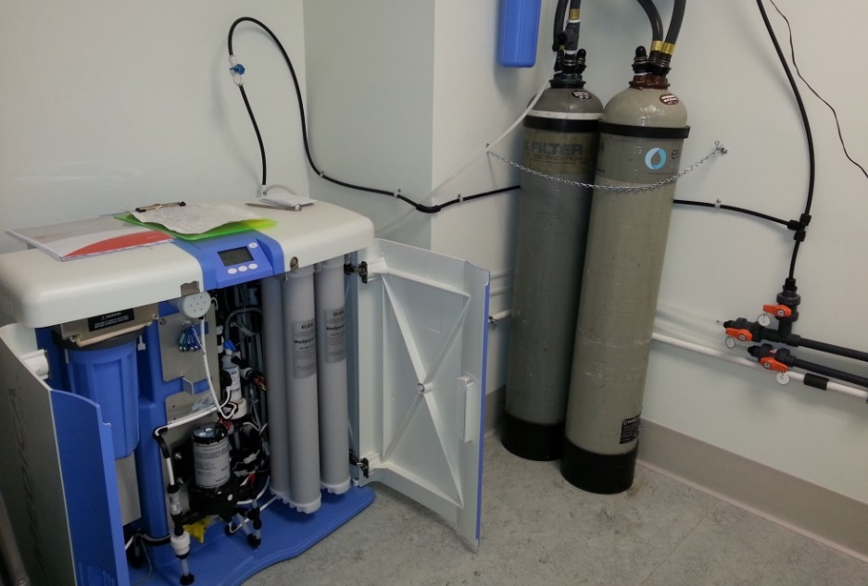

Valve #4, 5 & 6

Valve #1 & 2

Valve #3

* + - 1. Close valves 4 & 5 on the Medica Loop-(located on the wall near the AU680)
      2. Open Valve 6-(located on the wall near the AU680)

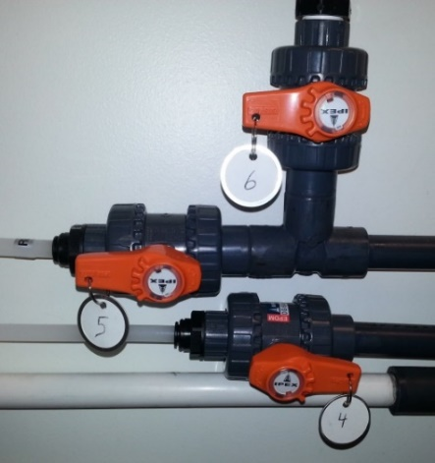

* + - 1. Open the doors of the Medica Pro. Close the valves 1 &2 these are blue /white that are on the right hand side toward the top.

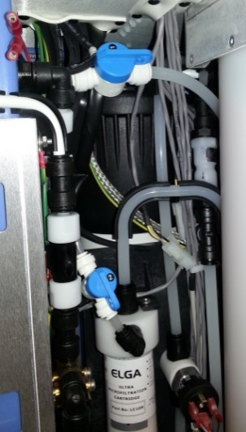

Valve #2

Valve #1

**16.3 ELGA** Medica 15 **(Hematology Area)**

Also serviced by Tower Equipment Company.

**If the unit is not operations, the Sysmex RU-20 diluting unit will not run.**

See the 5Labs RU-20 Procedure, (5 L Heme-3), Section 7.3 for instructions on changing from Cellpack DST to Cellpack DCL during a downtime of the ELGA system.

1. **RELATED DOCUMENTS**
   1. Refer to QPulse System or Document Detail Report for related Laboratory Policies, Procedures, and Master Forms